

Event Scheduling Training Guide

Quick Reference for End Users
This guide will assist you in logging in, requesting events, tracking approvals, making edits, and viewing event details in Coursedog. Follow the steps below to ensure your event is scheduled smoothly.
Contents
Getting Started (Login & Access) 2
Requesting an Event in Coursedog 2
Completing the Event Form 3
Recurring Meetings 6
Editing Events 7
Submitting & Tracking Requests 7
Approving Event Requests 9
Viewing Rooms & Calendars 10
Requesting an Event from the Public Events Site 10

Getting Started (Login & Access)
- Login.
  - Enter your TCU email and password for single sign-on
Note: Some events can be requested through the Public Events Site instead of logging into Coursedog.
Live link to Coursedog will be sent out once Coursedog is officially live on May 11th, 2026.

Requesting an Event in Coursedog
Starting a Request
- From the homepage, click “Request an Event.”
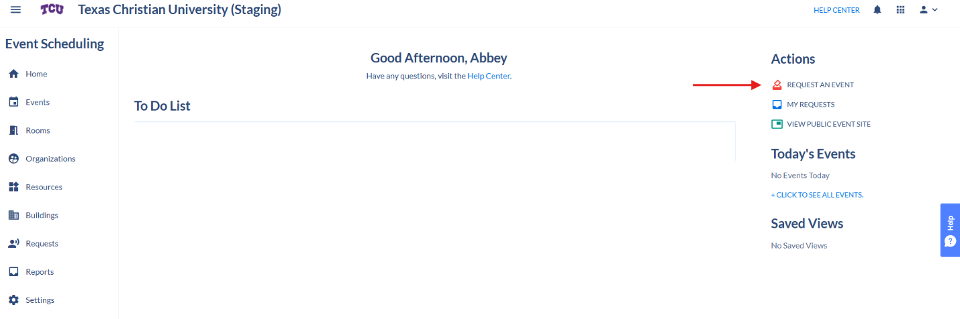

- Choose the correct Event Type and continue.
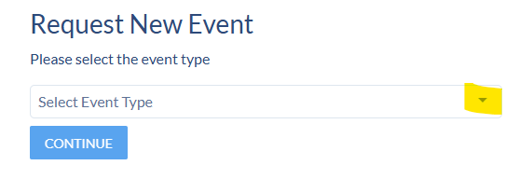

Completing the Event Form
The form is broken into sections (called “cards”). Fill out all required fields.
- Event Info: Event name, type, description.
- Meetings & Location:
  - Date(s) & time(s)
  - If repeating, set a recurrence pattern
  - Room/location (conflicts show in red)
  - Resources needed (chairs, AV, etc.) coming soon to some rooms
  - Indicate if it should appear on the Public Events Calendar
*Contacts: Add people to be notified (the requester is always included).
- Always fill out all required fields.
- The more complete your request, the faster it will be approved.
- Always double-check event details before submitting to avoid delays in approval.
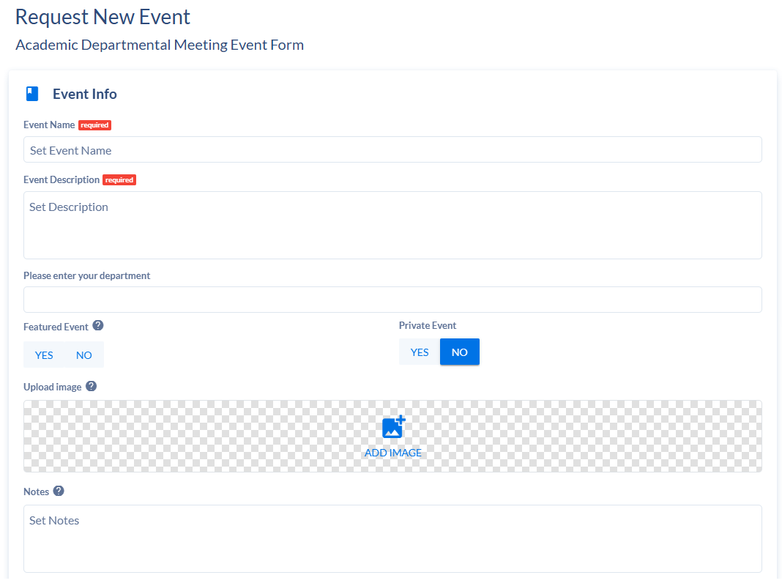

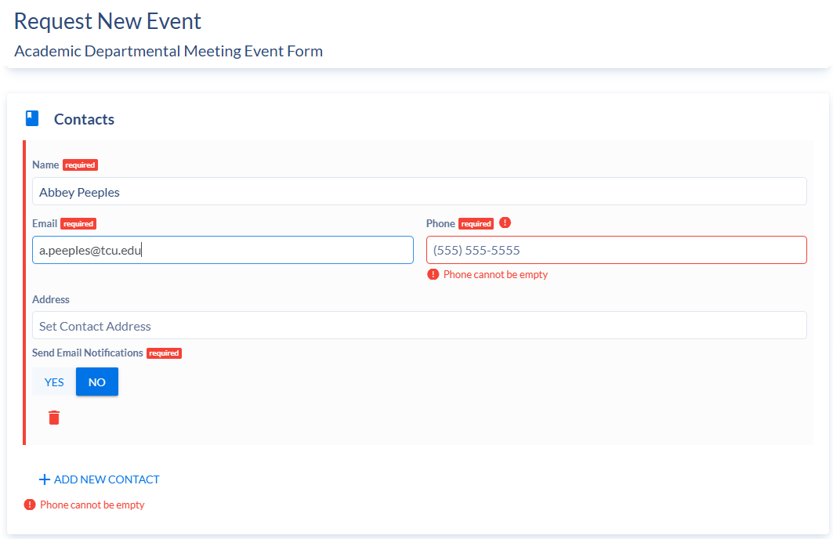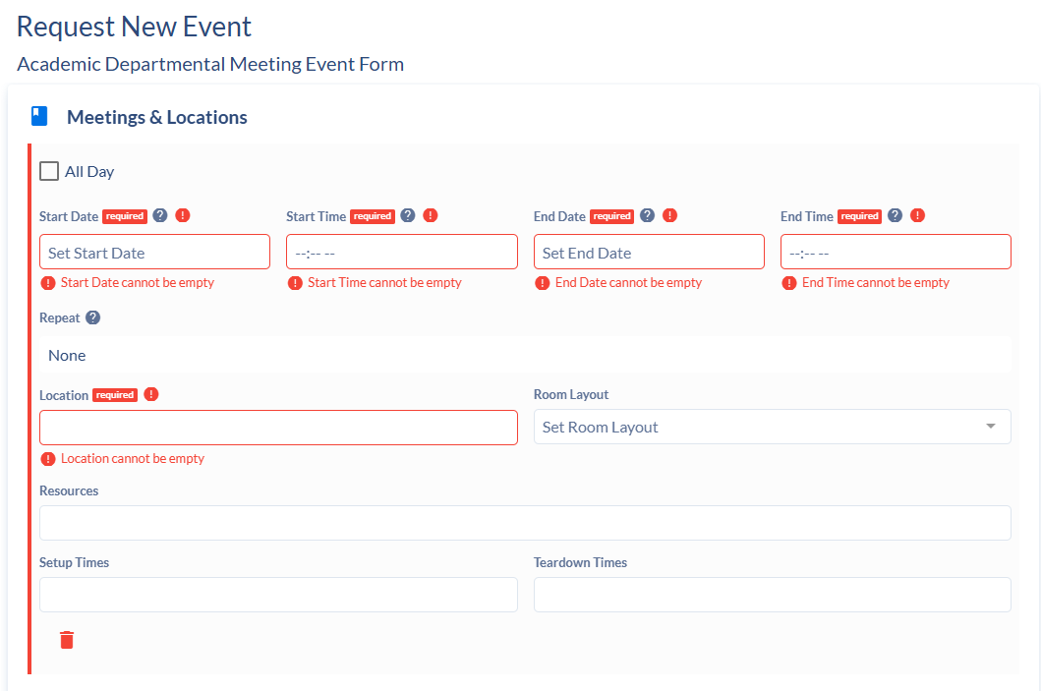

Recurring Meetings
- Expand recurrence patterns to see all dates.
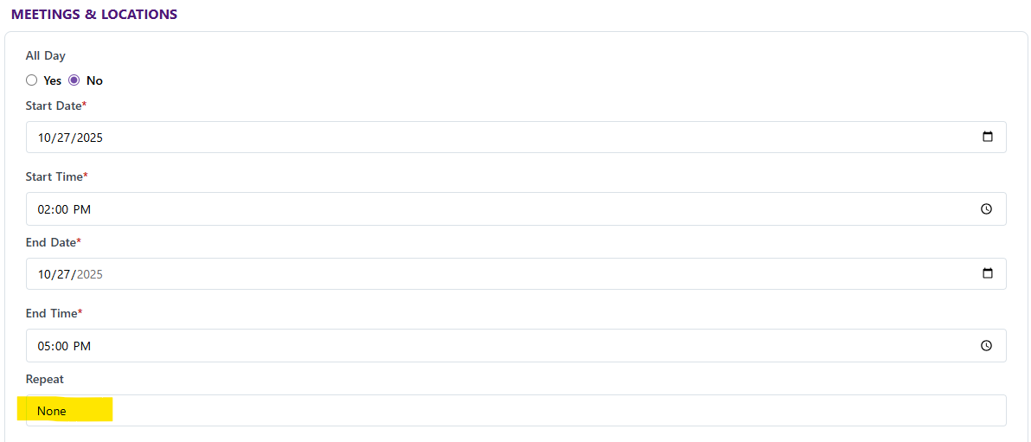
- Options:
  - Edit all meetings in the series
  - Edit a single meeting
  - Edit this and the following meetings
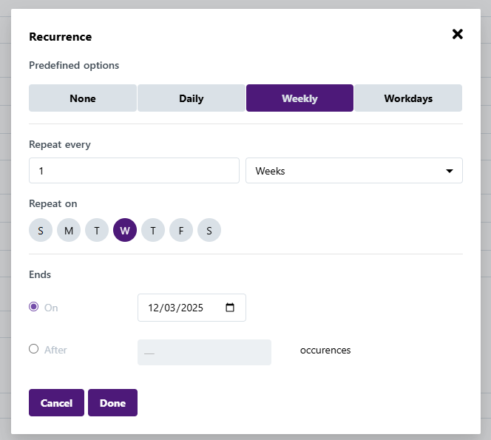

Editing Events

Editing a Submitted Request
- Go to My Requests.
- Click Edit Request (if allowed for your role).
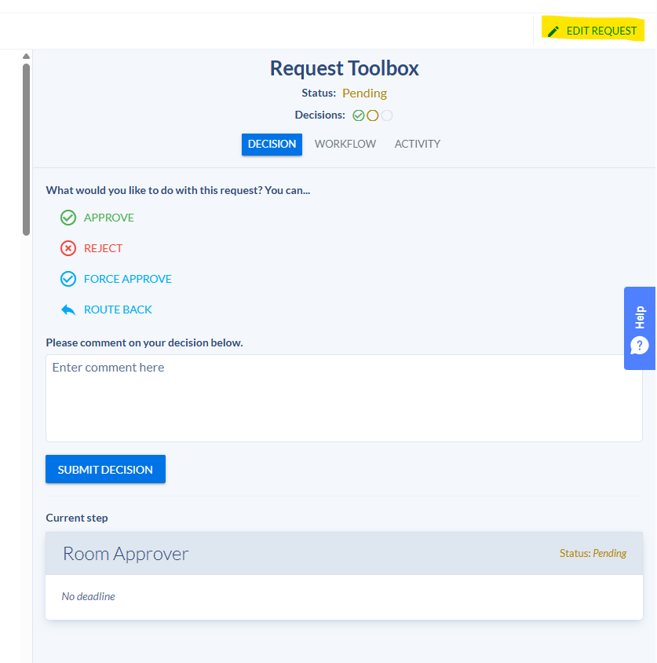
- Save changes (note: this may restart the approval process).

Submitting & Tracking Requests
- Click “Submit Event Request.”
- To track:
  - Go to Requests > Created by Me, or
  - Click “View Request” right after submitting.
You’ll see where your event is in the approval process and any reviewer notes.
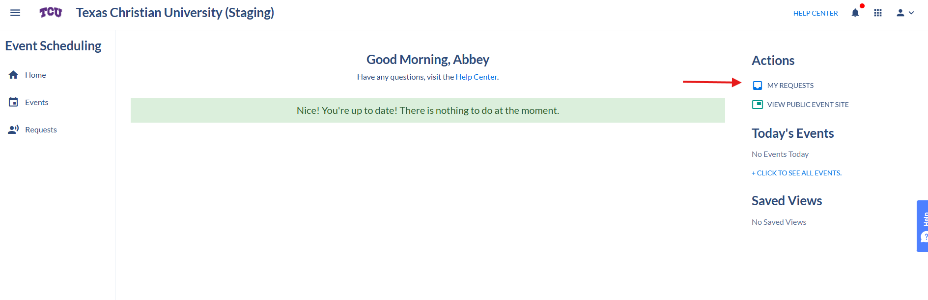

Approving Event Requests
(For approvers only)
- Go to Requests in the left menu.
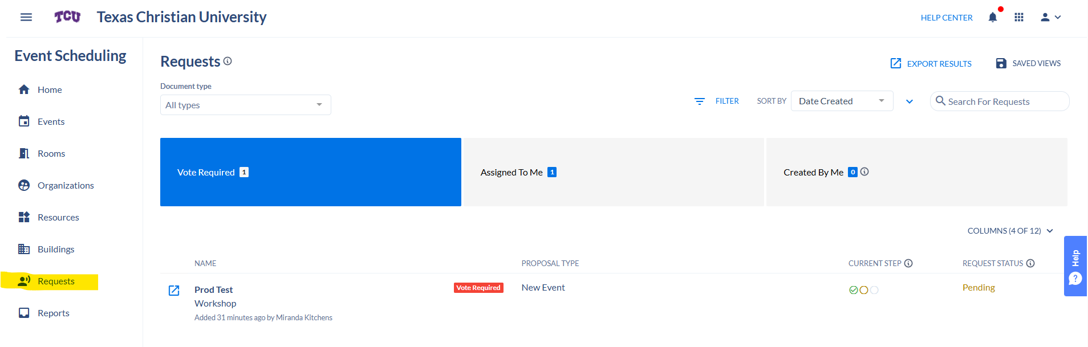
- Look under “Vote Required.”
- Select the request to:
  - Review details
  - Approve, deny, or request changes
*Approved events automatically appear on the calendar & Public Site.
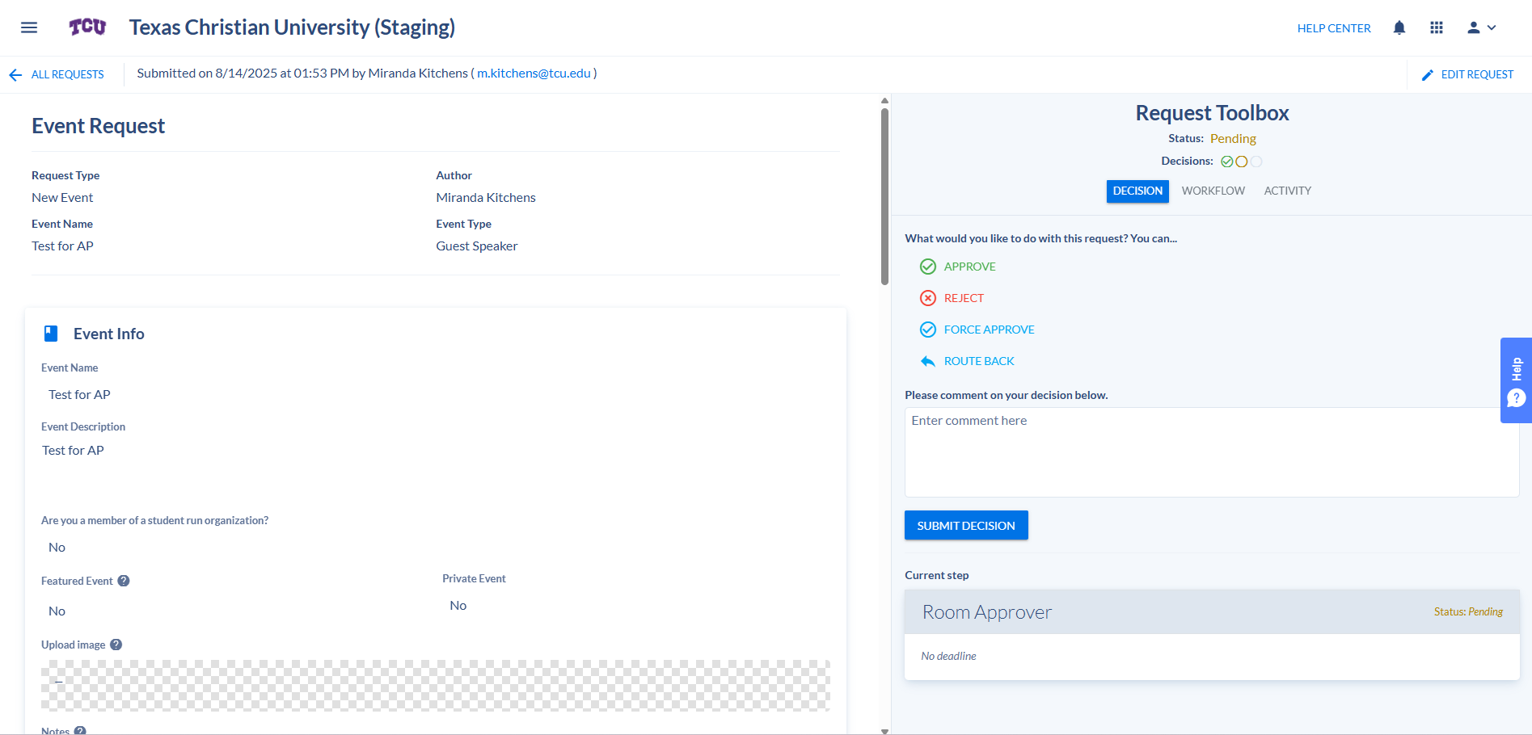

Viewing Rooms & Calendars
- Go to Events > Calendar View.
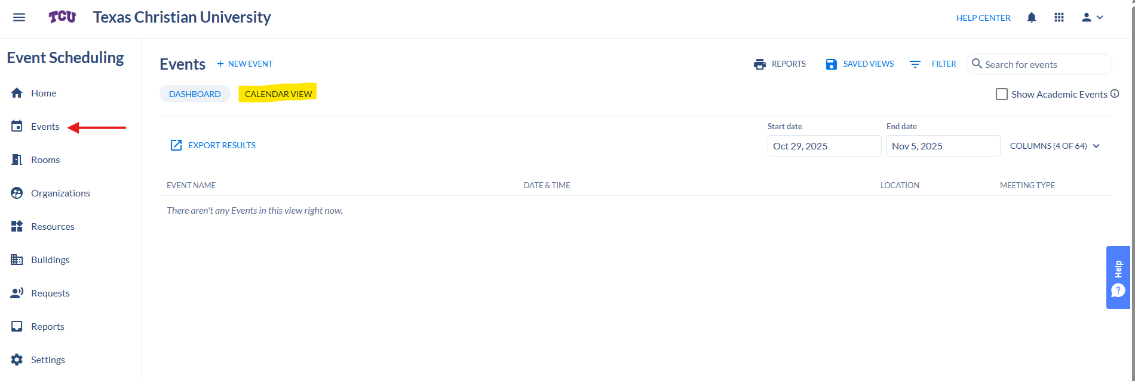
- To include classes/academic events, check “Show Academic Events.”
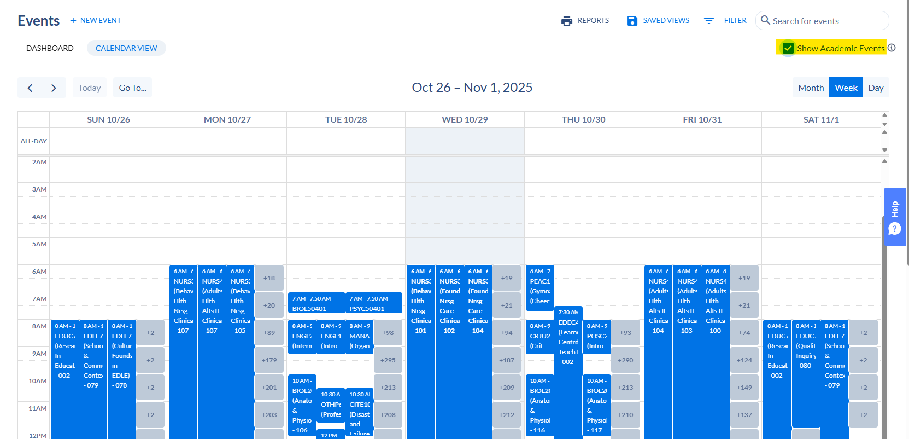
- Save custom views (ex: “Events + Classes”) under Saved Views.
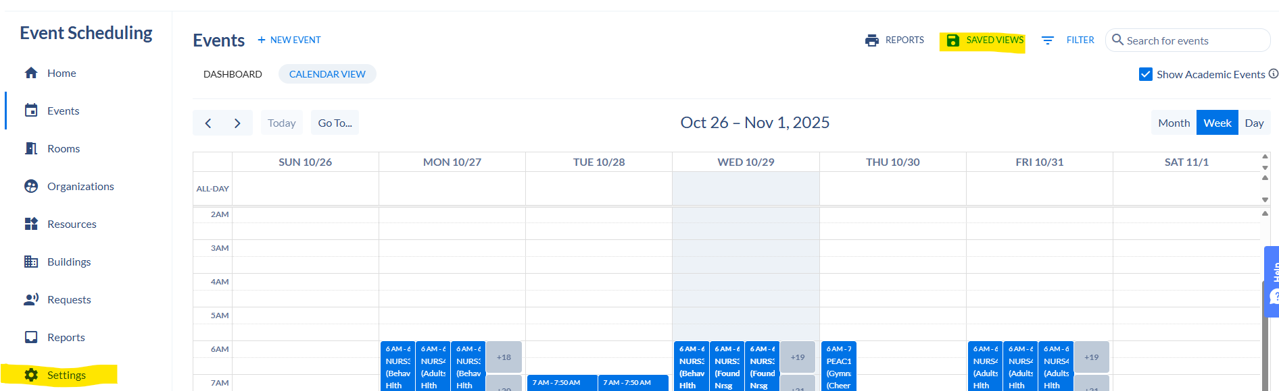
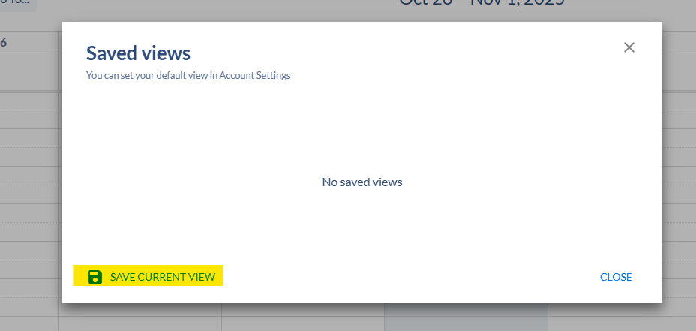
- To make a saved view your default: Account Settings > Default View.

Requesting an Event from the Public Events Site

- Go to your school’s Public Events page (link sent out on official launch date, May 11th, 2026).
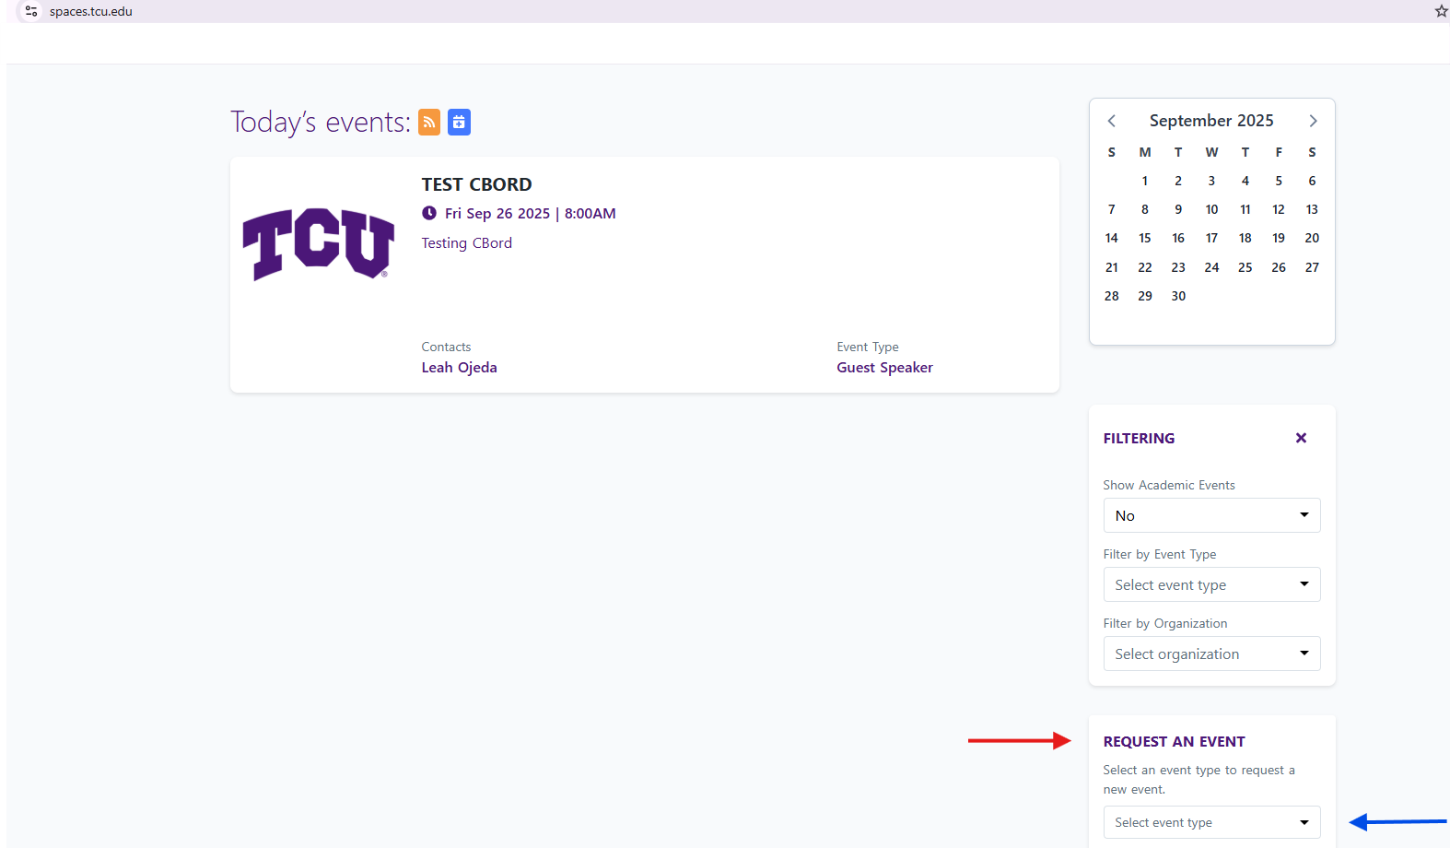
- Click “Create an Event.”
- Pick an Event Type and complete the form.
- Submit with your email address.
You’ll always get an email confirmation when you submit a request.

